Comp2151-Agile Software Development

Lab 05

Group 19:

Baek, Yoo Kyung 101282741

Hughes, Jesse 101244671

Jose, Naveen 101238395

Ngo, Tan Loi 101094358

Wang, Ke 101270848

Wang, Xiaolin 101283366

**Date submitted:**

Mar 14th, 2021

Patron Webpages

1. Patron Home

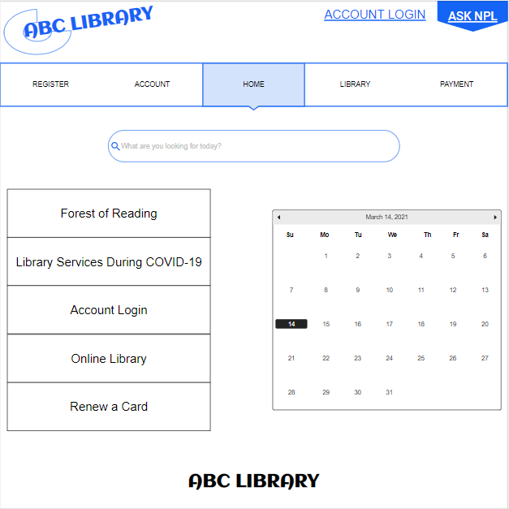

1. 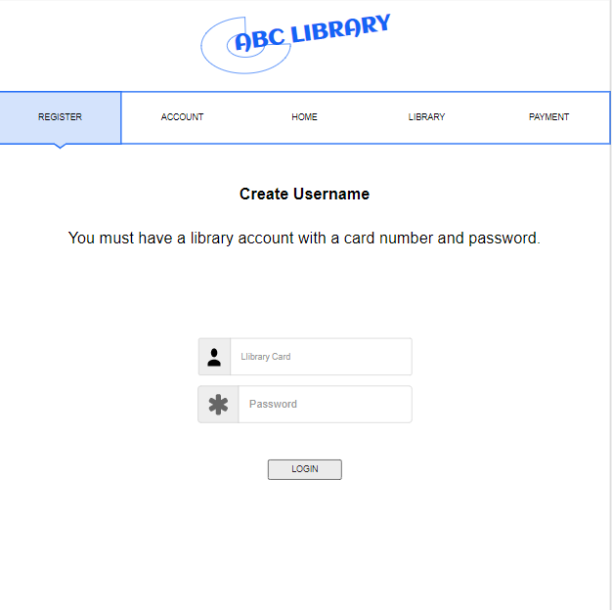Account Registration
2. 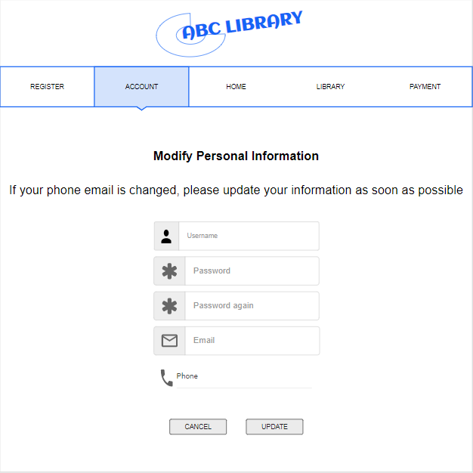Patron Information Modification
3. 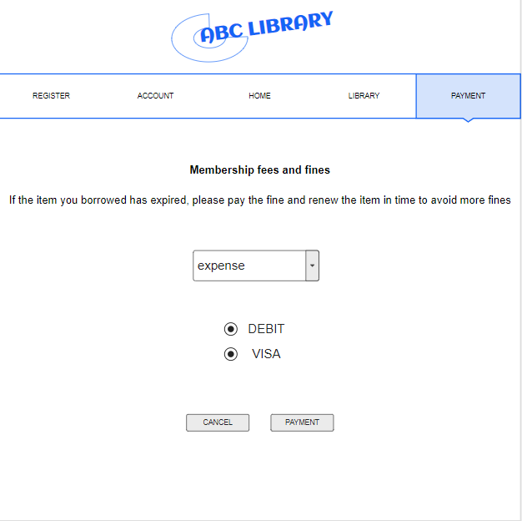Late Return Penalty Payment Page
4. 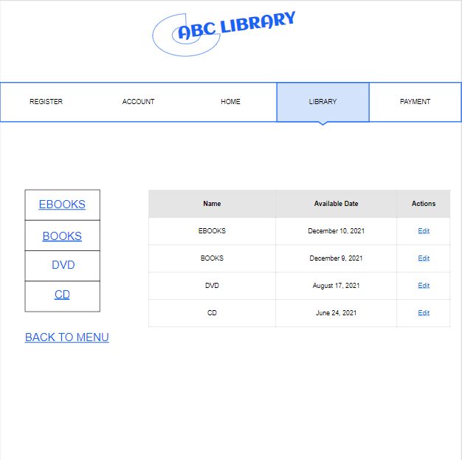Item Search and Results

Librarian/Manager Webpages